✅ Day 3 Plan
🔵 Part 1 — Subnetting Mastery (45–60 min)
Today focus on understanding block size and subnet jumps.
Step 1: Quick Revision (10 min)
Remember this table:
CIDR | Hosts | Block Size
/24 | 254 | 256
/25 | 126 | 128
/26 | 62 | 64
/27 | 30 | 32
/28 | 14 | 16
/29 | 6 | 8
/30 | 2 | 4
Understand how networks increment.
Example:
192.168.1.0/27
Block size = 32
Networks:
192.168.1.0
192.168.1.32
192.168.1.64
192.168.1.96
192.168.1.128

Step 2: Solve 20 Problems
Example questions:
- 192.168.5.0/27
- 192.168.5.64/27
- 10.0.0.128/26
- 172.16.10.0/28
- 192.168.2.0/29
For each find:
- Network ID
- Broadcast
- Usable range
- Total hosts
Target: < 90 seconds per problem

🔵 Part 2 — Linux Networking Commands (60–70 min)
Today you must become comfortable with network troubleshooting commands.
Open your Linux VM.

Step 1 — Check Network Interfaces
Run:
ip addr
Understand:
- interface name (eth0 / enp0s3)
- IP address
- subnet mask

Step 2 — Check Routing Table
Run:
ip route
Example output:
default via 192.168.1.1 dev enp0s3
192.168.1.0/24 dev enp0s3 proto kernel
Understand:
- default route
- local network
Write in notes:
What each line means.

Step 3 — Connectivity Tests
Run:
ping 8.8.8.8
Then:
ping google.com
Understand difference:
- IP ping tests network connectivity
- domain ping tests DNS + network

Step 4 — DNS Lookup
Run:
nslookup google.com
or
dig google.com
Observe:
- DNS server
- resolved IP

Step 5 — Trace Packet Path
Run:
traceroute google.com
See how packets travel through routers.
This is real networking visibility.

🔵 Part 3 — Mini Experiment (15 min)
Break DNS intentionally.
Edit:
/etc/resolv.conf
Change DNS to wrong value.
Now test:
ping google.com
Then test:
ping 8.8.8.8
Observe difference.
Fix DNS afterward.

🎯 Day 3 Output
By end of today you must have:
✅ 20 subnet problems solved
✅ Understand block size logic
✅ Know these commands:
ip addr
ip route
ping
nslookup
dig
traceroute
✅ Understand difference between:
- routing issue
- DNS issue

Part 2
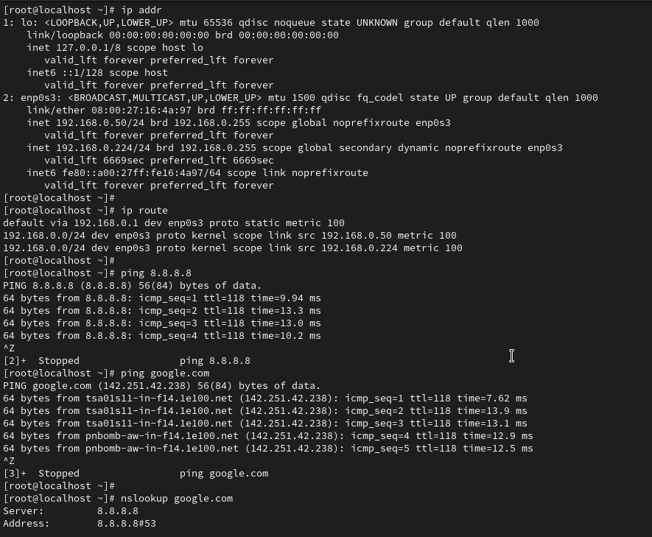
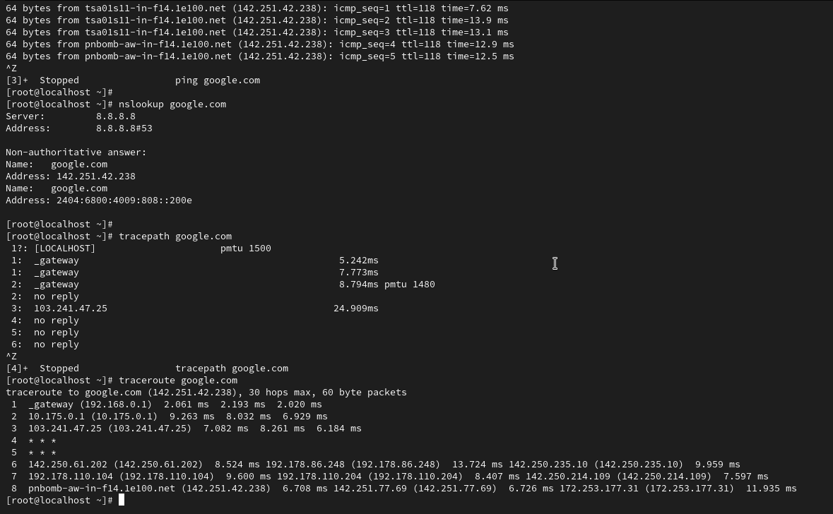
Part 3
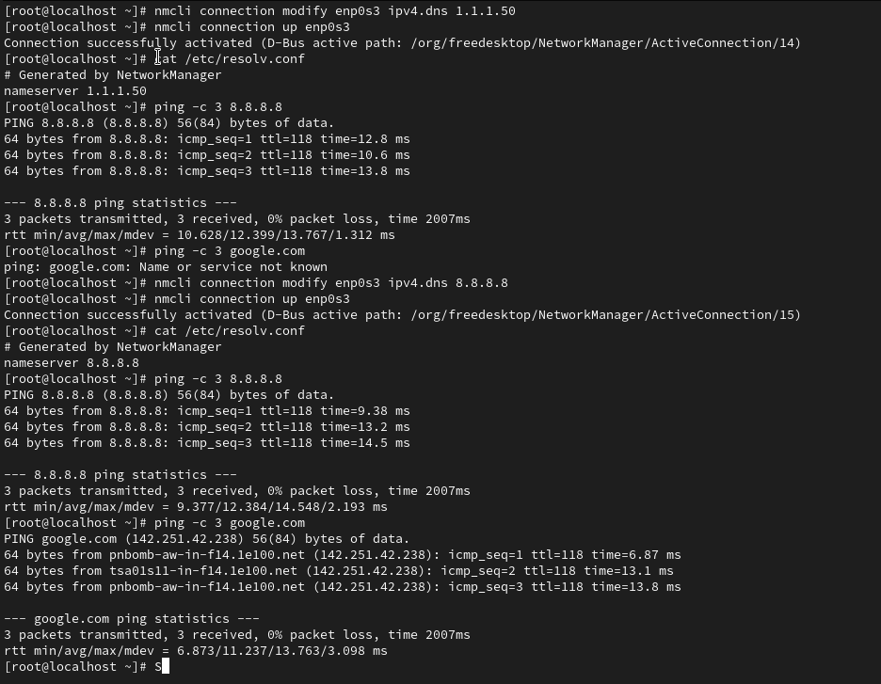

- What happens if DNS is wrong? I can still reach the internet by IP (numbers), but I cannot use website names.
- Difference between ping IP vs ping domain? Pinging an IP checks the physical road/gateway. Pinging a Domain checks the road AND the naming service (DNS)

1. The "Command Toolkit" Summary
These are the 6 essential tools you used today to see your network.
Command | Simple Purpose | What to look for
ip addr | My Identity | Look for enp0s3 and your IP (e.g., 192.168.0.50).
ip route | The Exit Door | Look for default via. This is your Gateway.
ping | The Heartbeat | Checks if a specific "house" (IP) is alive.
nslookup | The Phonebook | Asks the DNS: "What is the IP for this name?"
dig | The Deep Lookup | Same as nslookup, but gives more technical details.
traceroute | The GPS Path | Shows every "hop" (router) your data hits.

2. Routing vs. DNS (The "Broken" Scenarios)
This is the most important "Engineer" knowledge you gained from your experiments.
A. Routing Issue (Wrong Gateway)
- The Problem: Your "car" (data) can't find the exit ramp to the highway.
- Result: You are trapped.
- Test: Both ping 8.8.8.8 (IP) and ping google.com (Name) FAIL.
B. DNS Issue (Wrong Nameserver)
- The Problem: Your "car" can drive on the highway, but your "GPS" is broken.
- Result: You can reach the internet only if you know the number (IP).
- Test: ping 8.8.8.8 (IP) PASSES ✅, but ping google.com (Name) FAILS ❌.

